#1
A part of the structure for a factory automation system is a beam that spans 30.0 in as shown in the figure. The left load 𝐹1 = 1800 lb. remains constantly applied, while the right load 𝐹2 = 1800 lb. is applied and removed frequently as the machine cycles. Determine the stress ratio for point B and C. Also, use the maximum shear stress theory to select an aluminum alloy (3003) from Appendix 9 for the beam with design factor of 5. The bending is along the dashed line. Use Appendix 15 to get section modulus for HSS4×2×1/4. (15’ in total)
M_{max}
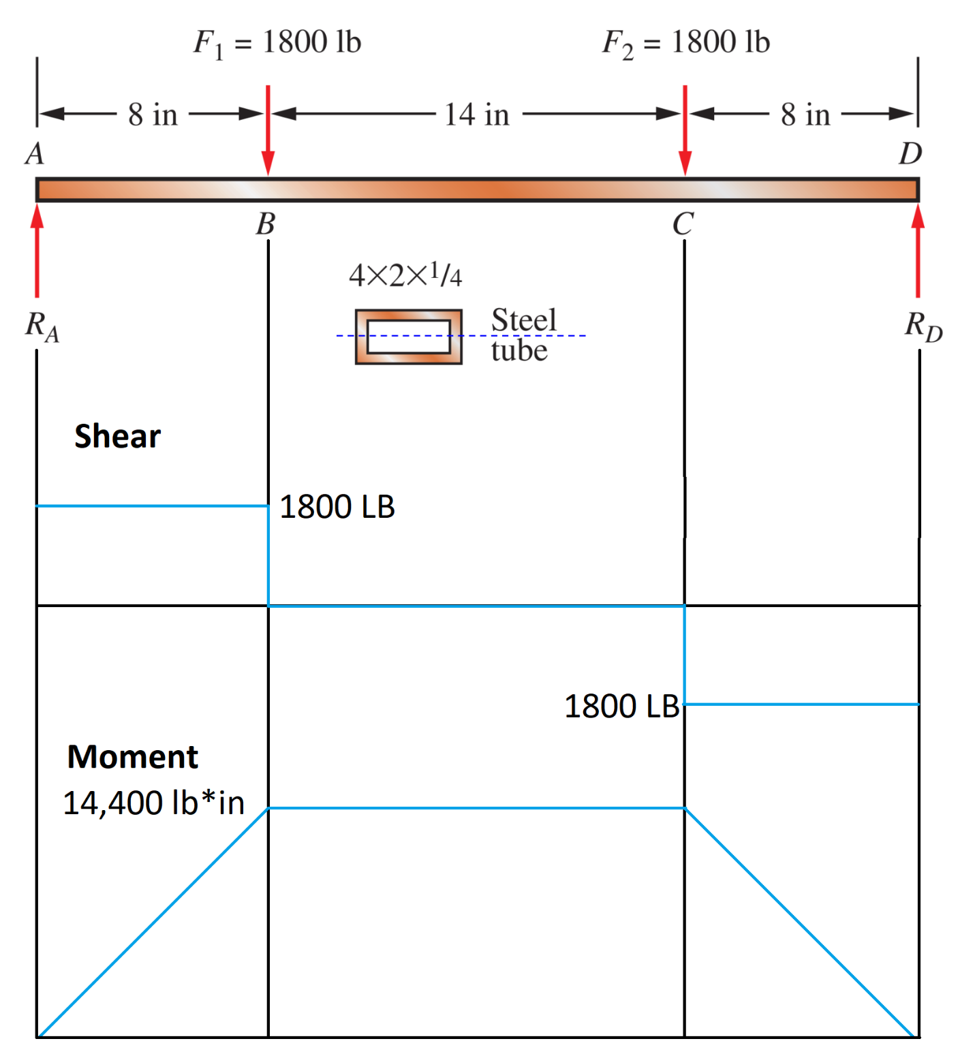
Mmin
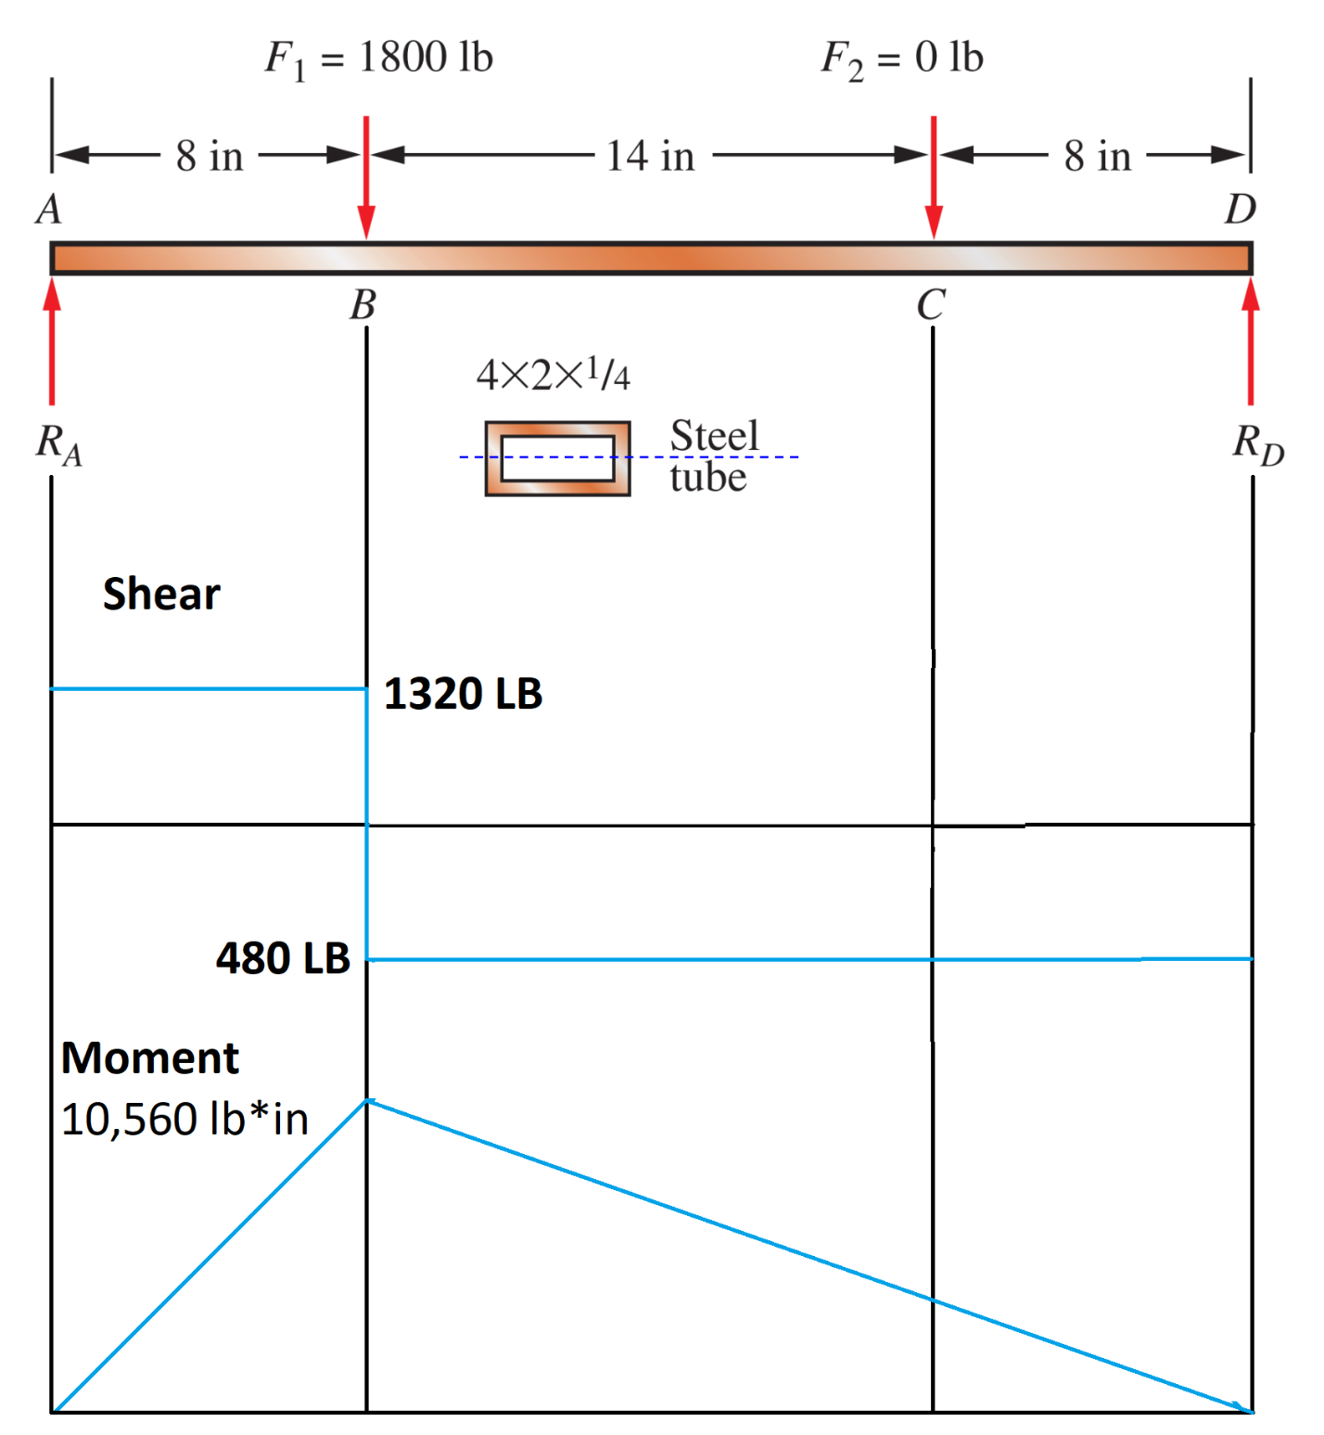

Section Modulus
Y-Y axis
1.48
$$σ_{max}=\frac{M_{max}}{S}=\frac{14400}{1.48}=\frac{360000}{37}≅9.73 ksi$$
$$σ_{min}=\frac{M_{min}}{S}=\frac{10560}{1.48}=\frac{264000}{37}≅7.135 ksi$$
$$R=\frac{σ_{min}}{σ_{max}}=\frac{\frac{264000}{37}}{\frac{360000}{37}}=\frac{11}{15}≅0.7\overline{33}$$
$$τ_{max}=\frac{σ_{1}-σ_{3}}{2}=\frac{180000}{37}≅4.865 ksi$$
$$s_{sy}≥N*σ_{e}=5*\frac{180000}{37}=24.34 ksi$$

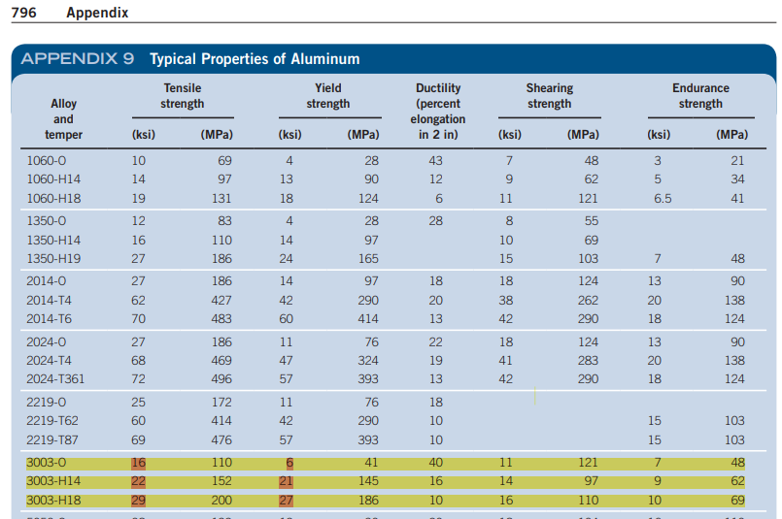
After consulting the table, we get that ONLY Material 3003-H18 meets the 24.34 ksi criteria for yield strength.
#2 Use Goodman criterion to determine the design factor for a beam with circular cross-section to carry a repeated central load of 2000 lb. Assume the material is wrought polished steel SAE 3140 (annealed). Take reliability as 90%. Stress concentration needs to be considered at point B. (15’ in total)
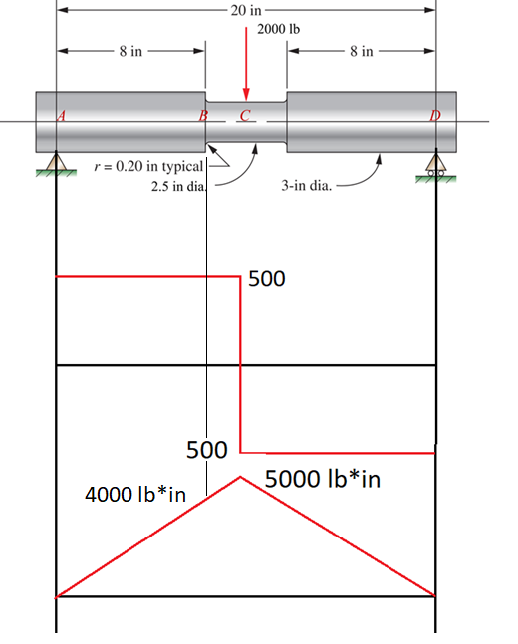

$$F_{a}=F_{m}=1000 lb$$
$$M_{c}=4000lb*in$$
$$σ_{m}=σ_{a}=\frac{M_{c}}{S}=\frac{4}{π*{2.5}^{3}/32}≅2.607ksi$$
$$r_{d}=\frac{D}{d}=\frac{3}{2.5}=1.2$$
$$\frac{r}{d}=\frac{0.2}{2.5}=0.08$$
From Appendix 3, we get that tensile strength, $s_{u}=95 ksi$
From Table 5-3, we get that $C_{R}= 0.9$
$$D_{e}=0.37D; D_{e}=1.11$$
From Table 5-4, we get that $C_{s}={\left(\frac{1.11}{0.3}\right)}^{-0.11}≅0.866$
From Page 178 and 180 in the textbook, $C_{st}= 1$
From Page 178 in the textbook, $C_{m}= 1$
From Appendix 18-5, we get that $K_{t}= 1.76$
From Figure 5-11A we get that $s_{n}≅ 47.5 ksi$
$$s_{n}^{'}=s_{n}C_{m}C_{st}C_{R}C_{s}=47.5*1*1*0.9*0.866≅37.0215 ksi$$
$$\frac{K_{t}σ_{a}}{s_{n}^{'}}+\frac{σ_{m}}{s_{u}}=\frac{1}{N}→\frac{\left(1.76*2.607\right)}{37.0215}+\frac{2.607}{95}=\frac{1}{N}→N=6.605$$

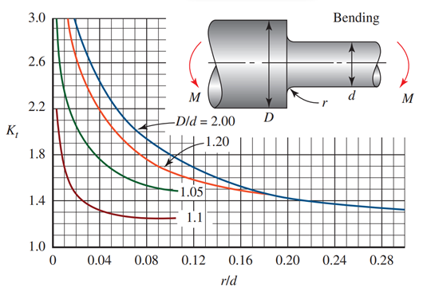

#3 A hydraulic cylinder pushes a heavy tool DURING the outward stroke, placing a compressive load of 400 lb in the piston rod. DURING the return stroke, the rod pulls on the tool with a force of 1600 lb. Compute the resulting design factor for the 0.50-in-diameter rod when subjected to this pattern of forces for many cycles. The material is SAE 4130 WQT 1300 steel (cold drawn). Take reliability as 99%. (10’ in total)
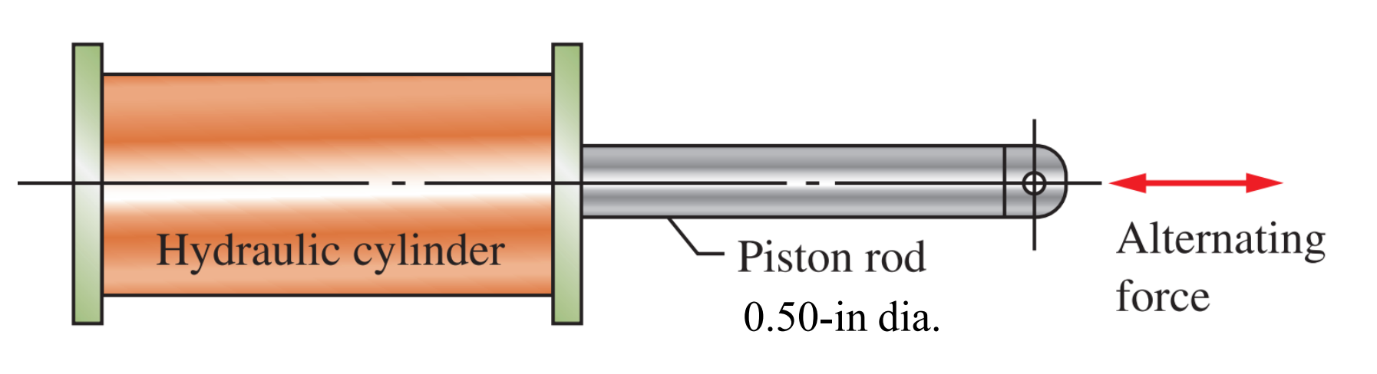
For constant circular section, there is no stress concentration, $K_{t}=1;$
From Table 5-3, we get that $C_{R}=0.81;$
From Page 178 in the textbook $C_{m}=1;$
From Page 178 and 180 in the textbook, $C_{st}=0.8;$
From Table 5-4, we get that $C_{s}=1;$
From Appendix 3, we get that tensile strength,$s_{u}=98;$
From Figure 5-11A we get that $s_{n}≅37$
$$s_{n}^{'}=s_{n}C_{m}C_{st}C_{R}C_{s}=37*1*0.8*0.81*1≅23.976 ksi$$
$$σ_{max}=\frac{1600}{\frac{π}{4}*{0.5}^{2}}=\frac{25.6}{π}=8.148ksi$$
$$σ_{min}=\frac{400}{\frac{π}{4}*{0.5}^{2}}=\frac{6.4}{π}=2.037ksi$$
$$σ_{a}=\frac{σ_{max}+σ_{min}}{2}=\frac{\frac{25.6}{π}+\frac{6.4}{π}}{2}=\frac{16}{π} ksi$$
$$σ_{m}=\frac{σ_{max}-σ_{min}}{2}=\frac{\frac{25.6}{π}-\frac{6.4}{π}}{2}=\frac{9.6}{π} ksi$$
$$\frac{K_{t}σ_{a}}{s_{n}^{'}}+\frac{σ_{m}}{s_{u}}=\frac{1}{N}→N=\frac{1}{\left(\frac{K_{t}σ_{a}}{s_{n}^{'}}+\frac{σ_{m}}{s_{u}}\right)}=\frac{1}{\left(\frac{1*\frac{16}{π}}{23.976}+\frac{\frac{9.6}{π}}{98}\right)}≅4.105$$
#4 The link is subjected to a tensile force that varies from 500 to 5500 lb. Evaluate the design factor if the link is made from SAE 1040 cold drawn steel. Take reliability as 90%. Stress concentration must be considered at both pin holes and the middle hole. (15’ in total)
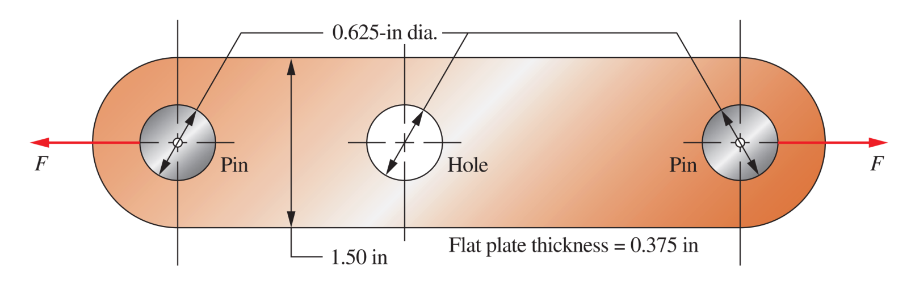
From Appendix 3, we get that Tensile Strength, $s_{u}=80 ksi$
From Figure 5-11A we get that Endurance Limit, $s_{n}≅30.5 ksi$
Size Factor: Because we are using Direct/Axial Tension, we get that $C_{s}=1$
Reliability Factor: From Table 5-3, we get that $C_{R}=0.90$
Type-of-Stress Factor: For axial tension, we get $C_{st}=0.80$
Material Factor: For wrought Steel, we get $C_{m}=1$
$$s_{n}^{'}=s_{n}C_{m}C_{st}C_{R}C_{s}=30.5*1*0.8*0.9*1=21.96 ksi$$

$$F_{a}=\frac{5500-500}{2}=2500 lb$$
$$F_{m}=F_{a}+F_{min}=500+2500=3000 lb$$
$$σ_{a}=\frac{F}{\left(w-d\right)t}=\frac{2.5}{\left(1.5-0.625\right)*0.375}=\frac{160}{21}$$
$$σ_{m}=\frac{F}{\left(w-d\right)t}=\frac{3.0}{\left(1.5-0.625\right)*0.375}=\frac{64}{7}$$

PART A (Stress concentration at both pin holes)
Given d and w are equal to 0.625 and 1.5, respectively, we find from Appendix A18-4(Curve B) that $K_{t}≅2.9$
$$\frac{K_{t}σ_{a}}{s_{n}^{'}}+\frac{σ_{m}}{s_{u}}=\frac{1}{N}→N=\frac{1}{\left(\frac{K_{t}σ_{a}}{s_{n}^{'}}+\frac{σ_{m}}{s_{u}}\right)}=\frac{1}{\left(\frac{\left(2.9*\frac{160}{21}\right)}{21.96}+\frac{\left(\frac{64}{7}\right)}{80}\right)}→N≅0.89$$
PART B (Stress concentration at middle hole)
Given d and w are equal to 0.625 and 1.5, respectively, we find from Appendix A18-4(Curve A) that $K_{t}≅2.22$
$$N=\frac{1}{\left(\frac{K_{t}σ_{a}}{s_{n}^{'}}+\frac{σ_{m}}{s_{u}}\right)}=\frac{1}{\left(\frac{\left(2.22*\frac{160}{21}\right)}{21.96}+\frac{\left(\frac{64}{7}\right)}{80}\right)}→N≅1.1305$$

#5 A standard 3-in schedule 40 steel pipe is proposed to be used to support the roof of a porch during renovation. Its length is 15 ft. The pipe is made from ASTM A501 structural steel. Determine the safe load on the pipe to achieve a design factor of 3 if the pipe is straight. All materials and cross-section properties can be found in Appendix in the textbook. (10’ in total)
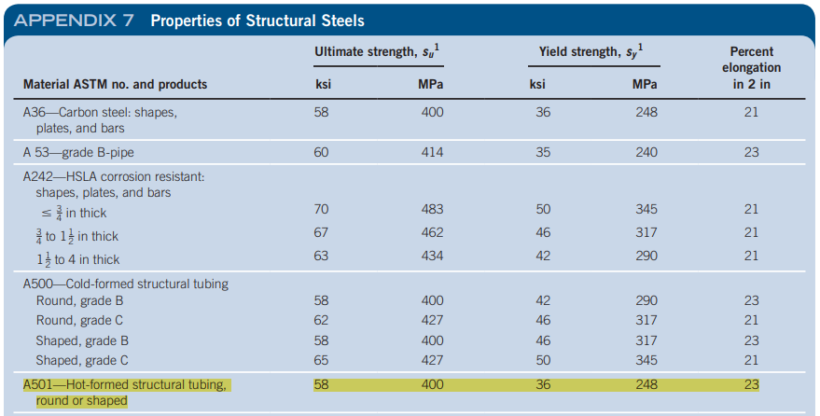
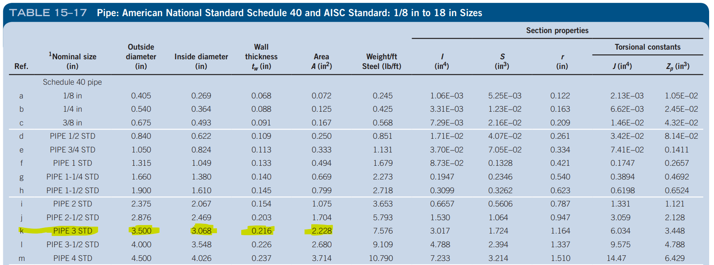
I am Assuming the column is pinned on both ends.
From Appendix 15-17, the radius of gyration is $r=1.164$
K=1
L=15*12=180in
Slenderness Ratio is $S_{r}=\frac{K*L}{r_{min}}=\frac{180}{1.164}=154.64$

$$s_{y}=36 ksi$$
For steel, it can be seen from Figure 6-5 that $C_{c}=127$
Because $S_{r}>C_{c}$, we can state that the column is long
For steel, $E=29*{10}^{6}psi=29*{10}^{3}ksi$
$$P_{cr}=\frac{π^{2}*E*I}{{\left(KL\right)}^{2}}=\frac{π^{2}*30*{10}^{3}*3.017}{{180}^{2}}=27.57kip$$
$$P_{a}=\frac{P_{cr}}{N}=\frac{27.57}{3}=9.19 kip$$

#6 Design a suitable diameter of a solid, round cross section for a machine link if it is to carry 12000 lb of axial compressive (centrical) load. The length of the link is 25 inch, and the two ends are pinned. Use a design factor of 3 and the material is SAE 1050 hot-rolled steel. (10’ in total)

From Appendix 3: $s_{y}=49 ksi, s_{u}=90 ksi;E=30*{10}^{3}ksi$
From Appendix 1(a) $Radius of gyration, r=\frac{D}{4};I=\frac{πD^{4}}{64};A=\frac{π}{4}*D^{2}$
From Fig 6-3, K=1
Slenderness Ratio is $S_{r}=\frac{K*L}{r_{min}}=\frac{1*25}{\frac{D}{4}}=\frac{100}{D}$
For steel, it can be seen from Figure 6-5 that $C_{c}≅110$
Find allowable load: $P_{a}=\frac{P_{cr}}{N}→P_{a}*N=P_{cr}→P_{cr}=12000*3=36000$
If column is short: $P_{cr}=A*s_{y}\left(1-\frac{s_{y}*S_{r}^{2}}{4*π^{2}*E }\right)→36=\frac{π}{4}*D^{2}*49\left(1-\frac{49*{\left(\frac{100}{D}\right)}^{2}}{4*π^{2}*30*{10}^{3} }\right)→D≅1.1615$
If column is long: $P_{cr}=\frac{π^{2}*E*I}{{\left(KL\right)}^{2}}→36=\frac{π^{2}*30*{10}^{3}*\frac{πD^{4}}{64}}{{25}^{2}}→D≅1.1154$
With either diameter being used, $S_{r}<C_{c}$, so we can state that the column is short and thus we use
$$D≅1.1615$$

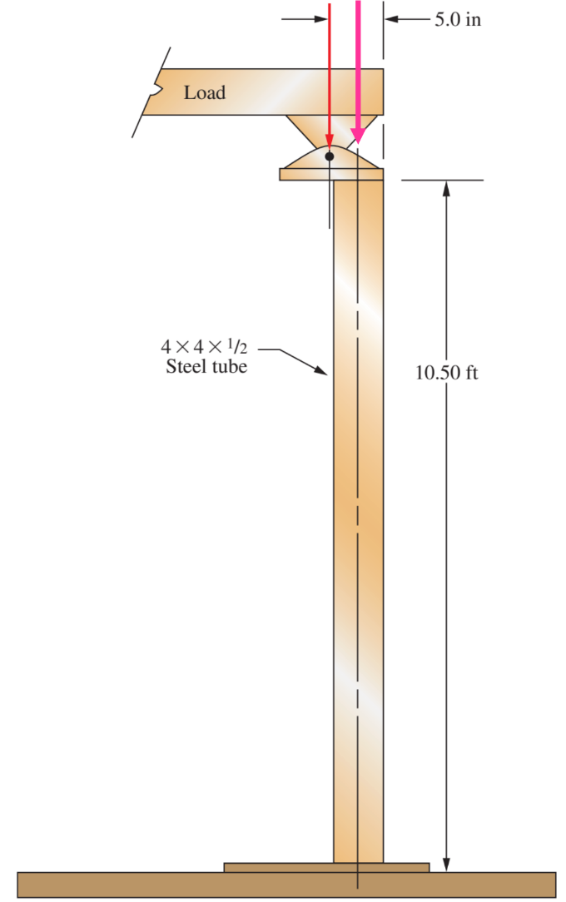
#7 A 4 × 4 ×1/2 steel hollow tubing column is made from ASTM A500 (Shaped) Grade B structural steel. First, determine the maximum allowable centrical load to achieve a design factor of 3. Second, to accommodate a special mounting restriction, sometimes the load is applied eccentrically as shown. Determine whether the column is still safe when the same allowable load is eccentrically applied. All materials and cross -section properties can be found in Appendix in the textbook. (10’ in total)
$$From Appx. 7, s_{u}=58;s_{y}=46;E=29*{10}^{3}$$
$$From Tbl. 15.14, ref\left(j\right), A=6.02;I=11.9;r=1.41;$$
$$From Fig. 6-3, K=1$$
$$\frac{KL}{r}=\frac{10.5*12*1}{1.41}=89.362$$
$$C_{c}=\sqrt{\frac{2π^{2}E}{s_{y}}}≅113.5$$
Because $C_{c}>\frac{KL}{r}$, the column is short
$$P_{cr}=A*s_{y}\left(1-\frac{s_{y}*S_{r}^{2}}{4*π^{2}*E }\right)=6.02*46\left(1-\frac{46*{89.362}^{2}}{4*π^{2}*29*{10}^{3}}\right)=188.07$$
$$P_{A}=\frac{P_{cr}}{3}=\frac{188.07}{3}=62.69$$

$$s_{y}=\frac{N*P_{a}}{A}\left(1+\frac{e*c}{r^{2}}\sec\left(\frac{K*L}{2*r}\sqrt{\frac{N*P_{a}}{A*E}}\right)\right)$$
$$c=\frac{w}{2}=\frac{4}{2}=2$$
$$e=5in-2 in=3in$$
$$s_{y}=\frac{188.07}{6.02}\left(1+\frac{3*2}{{1.41}^{2}}\sec\left(\frac{126}{2.82}\sqrt{\frac{188.07}{6.02*29*{10}^{3}}}\right)\right)=125.55 ksi$$
The column is unsafe under the eccentrically placed load because $125.55> s_{y}(46)$
#8 Using the boundary-lubricated approach, design a plain surface bearing to carry a radial load of 75 lb from a shaft having a minimum acceptable diameter of 0.50 in and rotating at 600 rpm. Use an 𝐿/𝐷 ratio of the bearing to be 1.5. Compute the 𝑝𝑉 factor and specify a material from Table 16–1. (5’ in total)
$$\frac{L}{D}=1.5;L=1.5*0.5=0.75;$$
$$p=\frac{F}{LD}=\frac{75}{0.75*0.5}=200$$
$$V=\frac{π*0.5*600}{12}=25π$$
$$pV=200*25π=5000π=15707$$
$$pV=2*15707=31414$$
Porous Bronze/oil impregnated meets the requirements

#9 Design a plain surface journal bearing to carry a steady radial load of 2.25 kN while the shaft rotates at 2200 rpm. The shaft stress analysis determines that the minimum acceptable diameter at the journal is 25 mm. Use 𝐿/𝐷 = 2.0 and specify the journal nominal diameter, the bearing length, the diametral clearance, the minimum film thickness of the lubricant during operation, the lubricant type that meets the requirement. Also compute the coefficient of friction, the friction torque, and the power dissipated as the result of friction. (10’ in total)
N=2200
$$Journal Nominal Diameter: D=25mm$$
$$Bearing Length: L=2D→L=50mm$$
$$From Fig. 16-4, Diametral Clearance:C_{d}≅0.04$$
$$h_{0}=0.00025D=0.00025*0.025=6.25 μm$$
$$C_{r}=\frac{C_{d}}{2}=\frac{0.04}{2}=0.02mm$$
$$\frac{R}{C_{r}}=\frac{12.5mm}{0.02mm}=625$$
$$Film thickness ratio:\frac{h_{0}}{C_{r}}=\frac{0.0063}{0.02}=0.315$$
$$RPM to RPS→\frac{2200}{60}=36.\overline{666}$$
$$From Fig. 16-8, Sommerfeld Number:S≅0.05$$
$$Viscosity: μ=\frac{S*p}{n_{s}*{\left(\frac{R}{C_{r}}\right)}^{2}}=\frac{0.05*1.8MPa}{36.\overline{666}*{625}^{2}}=0.006283636 Pa⋅s$$
$$At 70°C, SAE 5W meets the requirement$$

$$from Fig. 16-9, we get the coefficient of friction variable≅1.6$$
$$f=\frac{1.6}{\left(\frac{R}{C_{r}}\right)}=\frac{1.6}{625}=0.00256$$
$$Friction Torque:T_{f}=f*F*R=0.00256*2250*0.0125=0.072$$
$$P_{f}=T_{f}*n_{s}=0.072*36.\overline{666}\frac{rev}{s}*2π\frac{rad}{rev}≅16.587 W$$

